OUTDOOR ADVENTURES
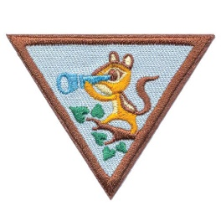

Vista SU Day Camp 2020
for Daisies and Brownies

Escondido Girl Scout Center
3050 Las Palmas Ave, Escondido
Saturday, April 25th, from 9am – 4pm

Cost $20 for girls & $5 for adults*
*ONLY 2 ADULTS PER TROOP due to space*

Scouts will earn Outdoor Adventurer & Eco Friend badges plus a fun patch
Space is limited to Registered 50 girls!
Fun-filled day will include Flag ceremony, singing, exploring nature, outdoor games, outdoor and wildlife stewardship activities and camp skills along with fun projects, snacks, a yummy lunch & more

With questions, please contact Kim Brower at kimbrower@cox.net
Turn in registration reservations no later than April 4th OR mail to Kim Brower, 1436 Cresthaven Place, Oceanside, 92056. Venmo Scott Romagnoli or one check per troop payable to: GIRLS SCOUTS by the 4/13 Service Unit Meeting
**********************************************
Leader Name: ________________________________ Troop Number: ____________
Program Level: ________________ Email: ___________________________________
Phone: ______________________ Number of Registered Girls Attending: ________
Number of Registered only Adults: ________ (maximum of 2)
Total Non-refundable Amount ($20/girl $5/adult): _______________

