Family Bike Ride

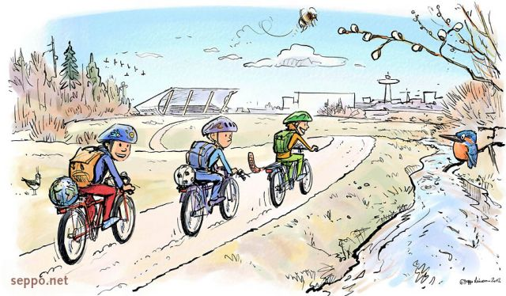
Come and celebrate spring with a Family bike ride on the San Luis Rey Bike Trail and finish at the playground on the Oceanside Harbor beach. Meet with your bicycles, gear and water - check in at Foussat path entry between 10-10:30AM, next to the skate park. Make sure to check out with the Vista Service Unit representative by noon and receive your patch.
Date: Sunday April19th Time: 10am-12pm Cost: $1 per scout for patch

Safety:
**Participants must wear helmets** Families/Groups: Please go over bike safety with your scouts!
Be sure to stay together as a group during the event and be sure to check out so we know everyone made it safely to the finish.
Registration Deadline: Bring to April 13 SU leader meeting or mail to: Jessica Frey 1476 Glencrest Dr San Marcos CA 92078 by deadline. Venmo Scott Romagnoli or one check per troop payable to: GIRL SCOUTS. Questions: email Jess Frey jbkfrey@gmail.com or text/call (858) 345-7542.
In case of rain, the event will be canceled or postponed
Leader Name: ________________________________ Troop Number: ____________
Program Level: ________________ Email: ___________________________________
Phone: ______________________ Number of Registered Girls Attending: ________
